

***LocalBites***

GOOD FOOD, GOOD FOLKS

BY SHAMBHAVI CHOUBEY

SHAMBHAVICHOUBEY18@GMAIL.COM

INDEX

* Introduction
* Object
* Tabs
* The lightening app
* Fields
* Flows
* Trigger
* Profiles
* Creation of users
* Public group
* Report types
* Reports
* Dashboards
* Sharing rules
* Homepage
* Conclusion

**Home Page of the App**

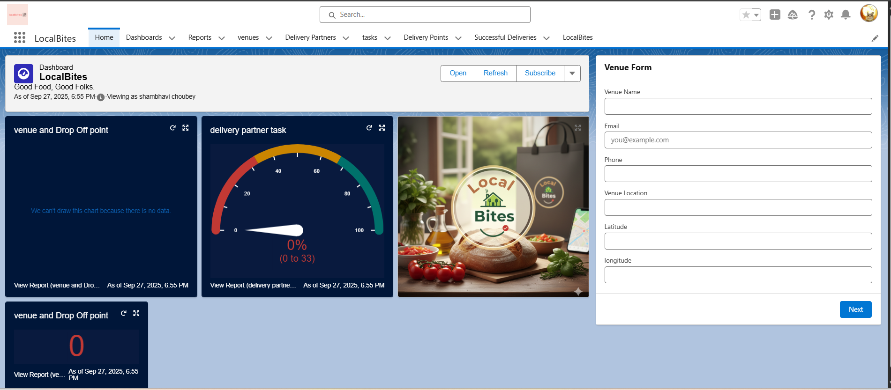

**Filling Venue form on the Dashboard**

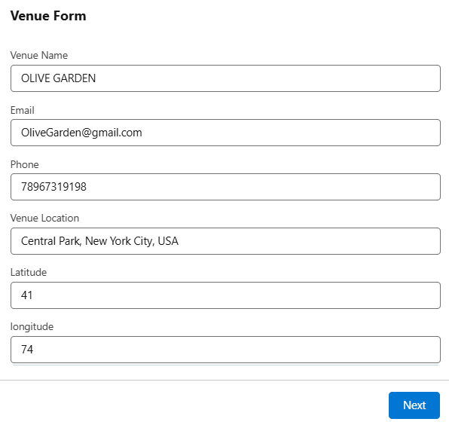

**Venue form Created**

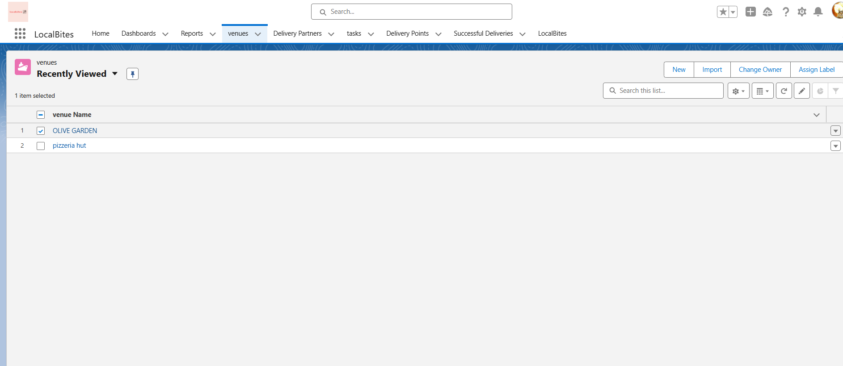

**Creating Report**

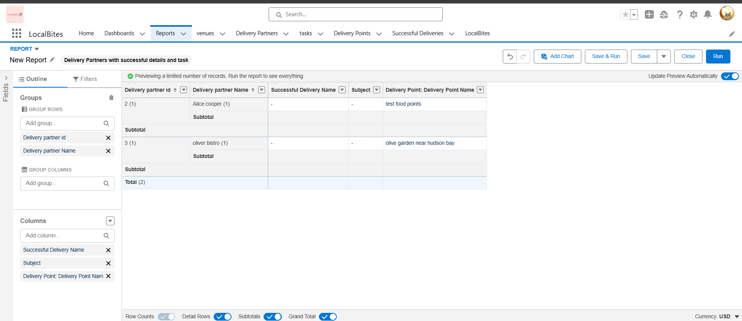

**Report Created**

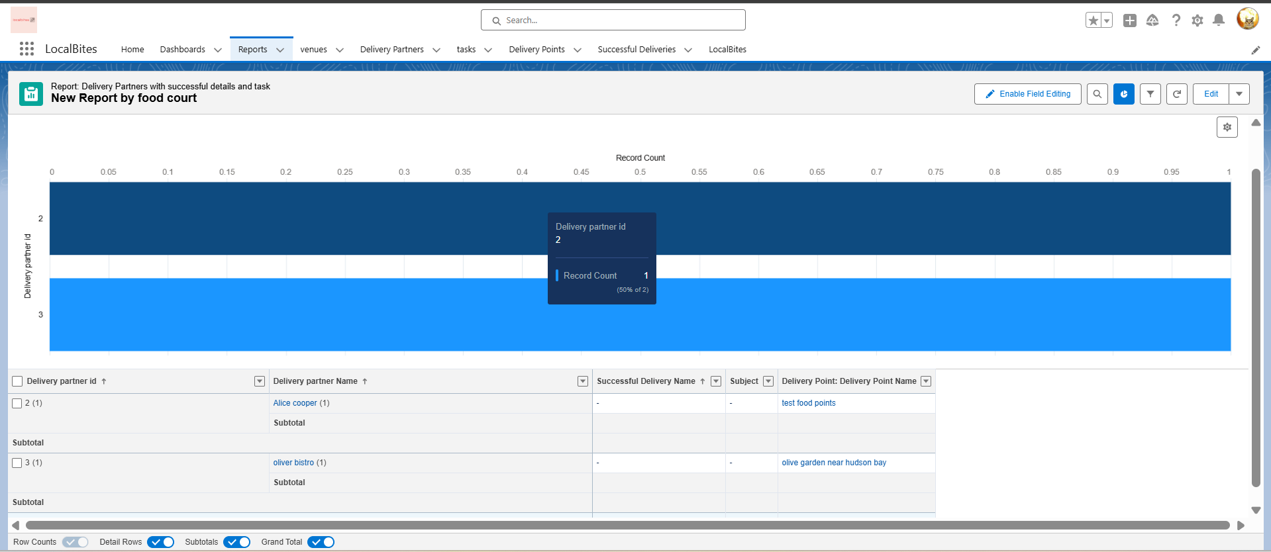

**Creation Of Delivery Point**

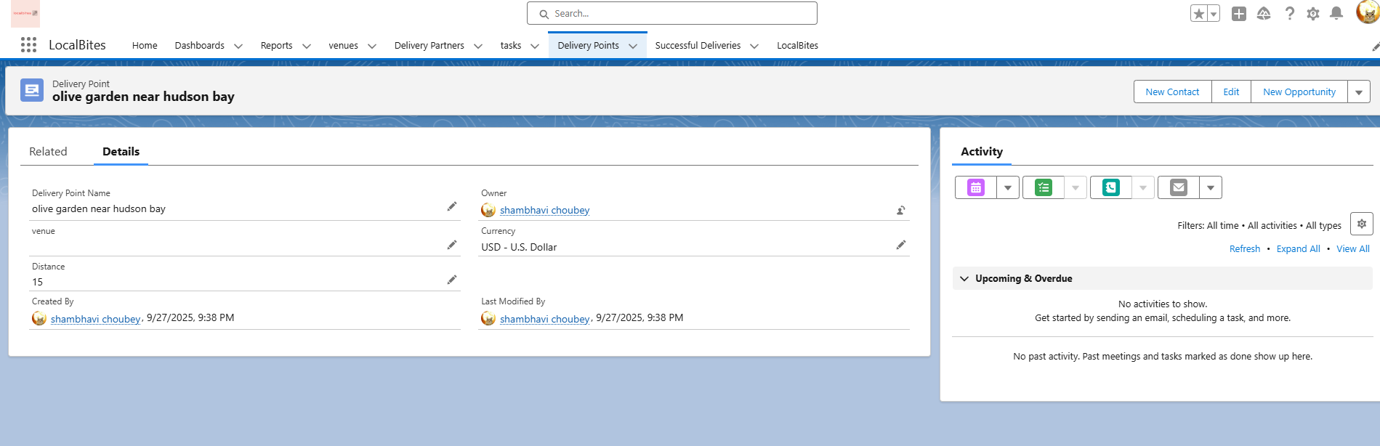

**Conclusion**

This Salesforce project exemplifies a comprehensive end-to-end implementation of a business application within the Salesforce ecosystem. By combining custom objects, fields, tabs, Lightning apps, flows, and Apex triggers, the project showcases both declarative and programmatic capabilities of Salesforce. The inclusion of profiles, user creation, public groups, sharing rules, and security controls ensures that the application adheres to best practices in data management and access control, reflecting real-world organizational requirements.

Furthermore, the development of custom report types, interactive reports, and dynamic dashboards highlights the platform’s power in providing actionable insights and supporting data-driven decision-making. The project also emphasizes user experience, with a well-organized homepage and Lightning app interface that allows users to efficiently navigate and access key functionalities.

Overall, this project not only demonstrates technical proficiency in Salesforce administration and development but also illustrates an understanding of business process automation, workflow optimization, and effective data visualization. It reflects the capability to design scalable, secure, and user-friendly solutions that deliver tangible business value, making it a strong testament to both problem-solving skills and practical application of Salesforce technologies.